***Alexander Molodyh***

***Class: CS361***

***Date: June 6, 2017***

***CS361 Lab3***

While executing the Radixsort, Binsort, and Mergesort algorithms alongside each other. I have noticed that Binsort performs much better than Radixsort and Mergesort algorithms. When the list becomes much larger, Binsort isn’t affected as much as Radixsort or Mergesort. On smaller list sizes the Mergesort beats both Radixsort and Binsort. But when the list starts becoming very large, then the Binsort outperforms both the Radixsort and Mergesort. According to the recorded data, Radix sort is also slower than Mergesort. I doesn’t matter if the list size is small or large, Mergesort is consistently faster than Radixsort by a small amount. Because of Binsort’s linear time of sorting the data, it is and will be faster than any sorting algorithm such as: Quicksort, Mergesort, and Radixsort.

The following table contains the results data from running the Radixsort, Binsort, Mergesort data. The sorting algorithms where ran 3 times on sizes of:

* 100,000
* 1,000,000
* 10,000,000

Then an average runtime is calculated from the three columns of each sorting algorithm.

|  |  |  |  |  |  |
| --- | --- | --- | --- | --- | --- |
| **Algorithm** | **Array Size** | **Run #1** | **Run #2** | **Run #3** | **Avg Runtime** |
| Radixsort | 100,000 | 14.4804 | 7.4447 | 6.9501 | 9.6250 |
| Mergesort | 100,000 | 8.9508 | 6.1846 | 5.4062 | 6.8472 |
| Radixsort | 1,000,000 | 67.7946 | 71.8768 | 75.4207 | 71.6974 |
| Mergesort | 1,000,000 | 56.9583 | 57.0155 | 59.4051 | 57.7929 |
| Radixsort | 10,000,000 | 700.4251 | 793.6850 | 733.4637 | 742.5246 |
| Mergesort | 10,000,000 | 678.3160 | 678.4101 | 678.3855 | 678.3705 |
| Binsort | 100,000 | 22.1938 | 25.9605 | 12.1608 | 20.1050 |
| Mergesort | 100,000 | 5.3574 | 5.0942 | 5.4018 | 5.2845 |
| Binsort | 1,000,000 | 23.2534 | 22.1499 | 26.8540 | 24.0857 |
| Mergesort | 1,000,000 | 57.0474 | 58.1578 | 58.9301 | 58.0451 |
| Binsort | 10,000,000 | 111.1672 | 110.7620 | 111.1899 | 111.0397 |
| Mergesort | 10,000,000 | 676.2537 | 677.0539 | 676.7719 | 676.6932 |

**The following chart represents the runtime difference between the Radixsort and Mergesort algorithms**.

**The following chart represents the average runtime between the Binsort and Mergesort algorithms.**

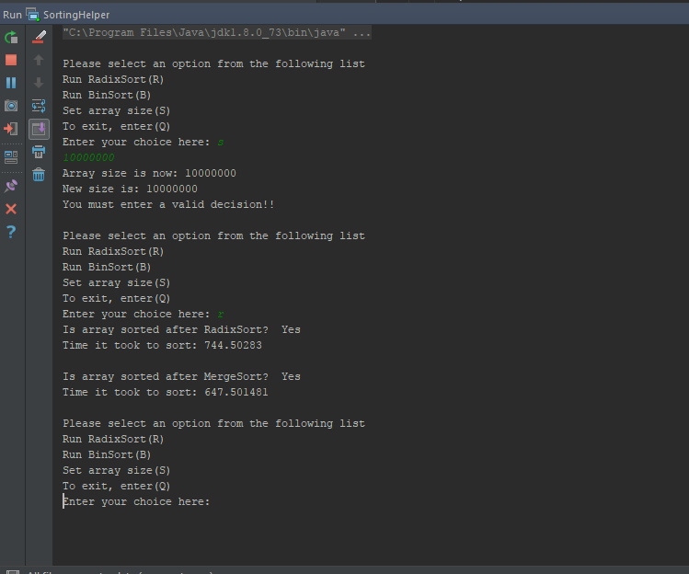**The following screenshot is the output of an array being sorted with the Radixsort of size 10,000,000.**

**The code for the previous screenshot is:**

**public static void** main(String[] args)  
{  
 **int** arraySize = 10000000;  
 InputRoutine inputRoutine = **new** InputRoutine(arraySize);  
 QuickMergeSort qmSort = **new** QuickMergeSort();  
 SortManager sm = **new** SortManager();  
 FA dfa;  
  
 State q0 = State.*makeState*(0, **true**);  
 State q1 = State.*makeState*(1);  
  
 ArrayList<State> Q = **new** ArrayList<>();  
 Q.add(q0);  
 Q.add(q1);  
  
 ArrayList<State> F = **new** ArrayList<>();  
 F.add(q0);  
  
 String language = **"00001001"**;  
  
 State[][] states = {{q0, q1}, {q0, q1}};  
  
 **int**[] largeArray = inputRoutine.getIntegerList();  
 **boolean** done = **false**;  
  
 **while**(!done)  
 {  
 String sizeResponse = **""**;  
 **int**[] integerList = inputRoutine.getIntegerList();  
  
 System.***out***.println(**"\nPlease select an option from the following list"**);  
 System.***out***.println(**"Run RadixSort(R)\nRun BinSort(B)"**);  
 System.***out***.println(**"Set array size(S)"**);  
 System.***out***.println(**"Run DFA(D)"**);  
 System.***out***.println(**"To exit, enter(Q) "**);  
 System.***out***.print(**"Enter your choice here: "**);  
  
 Scanner scan = **new** Scanner(System.***in***);  
 String response = scan.next();  
  
 *//This will change the array size* **if**(response.equalsIgnoreCase(**"S"**))  
 {  
 **try** {arraySize = scan.nextInt();}  
 **catch**(Exception e){};  
  
 System.***out***.println(**"Array size is now: "** + arraySize);  
 inputRoutine.setArraySize(arraySize);  
 inputRoutine.reReadFile();  
 largeArray = inputRoutine.getIntegerList();  
  
 System.***out***.println(**"New size is: "** + largeArray.**length**);  
 }  
  
 *//This will run the Radixsort* **if**(response.equalsIgnoreCase(**"R"**))  
 {  
 **int**[] copyList = Arrays.*copyOf*(integerList, integerList.**length**);  
 integerList = sm.radixSort(integerList);  
  
 System.***out***.println(**"Is array sorted after RadixSort? "** +

((*isSorted*(integerList) ? **" Yes"** : **" No"**)));  
 System.***out***.println(**"Time it took to sort: "** + sm.getRadixTime() + **"\n"**);  
  
 *//Make a copy of the original array to be sorted in the Mergesort* copyList = qmSort.mergeSort(copyList);  
  
 System.***out***.println(**"Is array sorted after MergeSort? "** +

((*isSorted*(copyList) ? **" Yes"** : **" No"**)));  
 System.***out***.println(**"Time it took to sort: "** + qmSort.getMergeSortTime());  
 }  
 **else if**(response.equalsIgnoreCase(**"B"**))*//This will run the Binsort* {  
 **int**[] copyList = Arrays.*copyOf*(integerList, integerList.**length**);  
 integerList = sm.binSort(integerList);  
  
 System.***out***.println(**"Is array sorted after BinSort? "** +

((*isSorted*(integerList) ? **" Yes"** : **" No"**)));  
 System.***out***.println(**"Time it took to sort: "** + sm.getBinTime() + **"\n"**);  
  
 *//Make a copy of the original array to be sorted in the Mergesort* copyList = qmSort.mergeSort(copyList);  
  
 System.***out***.println(**"Is array sorted after MergeSort? "** +

((*isSorted*(copyList) ? **" Yes"** : **" No"**)));  
 System.***out***.println(**"Time it took to sort: "** + qmSort.getMergeSortTime());  
 }  
 **else if**(response.equalsIgnoreCase(**"D"**))  
 {  
 System.***out***.print(**"Enter language String: "**);  
 language = scan.next();  
 dfa = **new** FA(Q, language, states, q0, F);  
  
 System.***out***.println(**"Does DFA accept string "** + language + **": "** +  
 ((dfa.isValidString(language, **true**) ? **" Yes"** : **" No"**)));  
 }  
 **else if**(response.equalsIgnoreCase(**"Q"**))*//Quit the program* done = **true**;  
 **else** System.***out***.println(**"You must enter a valid decision!!"**);  
 }  
}

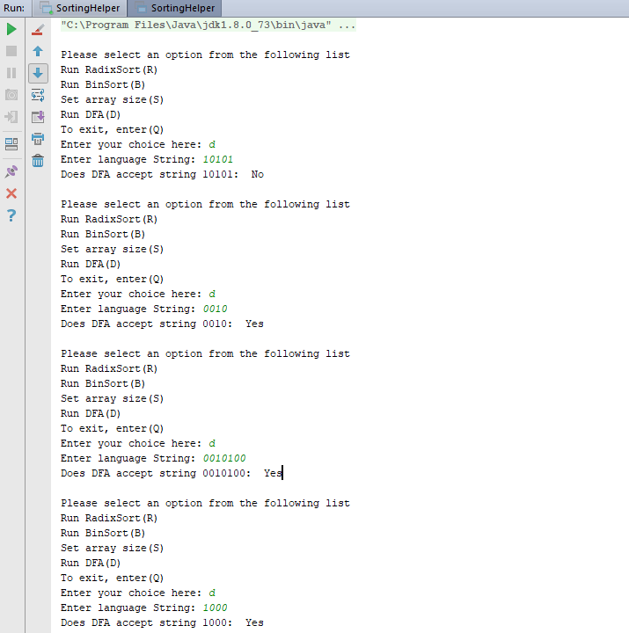**The following is a screenshot of the DFA output**.

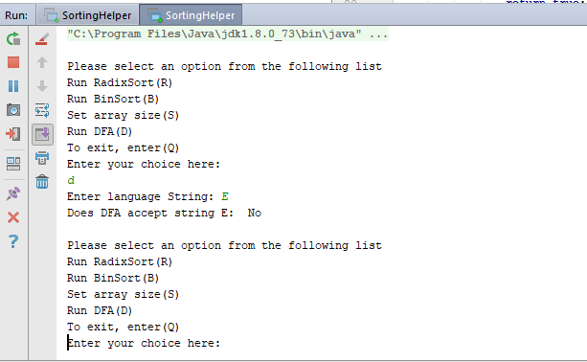**The following screenshot is from running the DFA on “E”.**

**The following code is the Radixsort and Binsort.**

**public class** SortManager  
{  
 **private final int INCREMENTER_MOD** = 10;  
 **private long radixTime** = 0;  
 **private long binTime** = 0;  
  
  
  
 */**  
 *radixSort will perform a Radixsort algorithm on the given array to sort it.  
 \** ***@param arr*** *An integer array that will be sorted.  
 */* **public int**[] radixSort(**int**[] arr)  
 {  
 **radixTime** = getMillis();  
 **int** n = arr.**length**;  
  
 *//Get the largest element in the list to know how long the number is* **int** max = getLargestElement(arr, n);  
  
 *//Loop through the largest number length* **for**(**int** i = 1; (max / i) > 0; i *= 10)  
 arr = radixHelper(arr, n, i);  
  
 **radixTime** = getMillis() - **radixTime**;  
  
 **return** arr;  
 }  
  
 *//gets the largest integer in the list and returns it* **private int** getLargestElement(**int**[] arr, **int** size)  
 {  
 **int** largest = arr[0];  
  
 **for**(**int** i = 0; i < size; i++)  
 **if**(arr[i] > largest)  
 largest = arr[i];  
  
 **return** largest;  
 }  
  
 *//This is a helper method for the Radixsort method* **private int**[] radixHelper(**int**[] arr, **int** n, **int** div)  
 {  
 *//Crete helper array to store temporary output elements* **int**[] helperArr = **new int**[n];  
 **int**[] incrementerArr = **new int**[**INCREMENTER_MOD**];  
 Arrays.*fill*(incrementerArr, 0);  
  
 *//Store the count of occurrences in incrementArr* **for**(**int** i = 0; i < n; i++)  
 incrementerArr[ (arr[i] / div) % **INCREMENTER_MOD** ]++;  
  
 *//Change each index so that it contains the actual position of the current digit* **for**(**int** i = 1; i < incrementerArr.**length**; i++)  
 incrementerArr[i] += incrementerArr[i - 1];  
  
 *//Build the output array* **for**(**int** i = n - 1; i >= 0; i--)  
 {  
 **int** helperIndex = incrementerArr[ (arr[i] / div) % **INCREMENTER_MOD** ] - 1;  
 helperArr[ helperIndex ] = arr[i];  
 incrementerArr[ (arr[i] / div) % **INCREMENTER_MOD**]--;  
 }  
  
 *//Copy the helperArr in to the arr to be returned* **for**(**int** i = 0; i < n; i++)  
 arr[i] = helperArr[i];  
  
 **return** arr;  
 }  
  
 **public static void** print(**int**[] arr)  
 {  
 **for**(**int** i = 0; i < arr.**length**; i++)  
 System.***out***.print(arr[i] + **", "**);  
 }  
  
 *///////////////////////Bin Sort//////////////////////////  
  
 /**  
 * binSort performs a Binsort algorithm on the given array to be sorted  
 \** ***@param arr The array to be sorted.*** *\** ***@return Am onteger array of sorted elements.*** *\*/* **public int**[] binSort(**int**[] arr)  
 {  
 **binTime** = getMillis();  
 **int** n = arr.**length**;  
 **int** arraySize = getLargestElement(arr, n);  
 **int**[] helperArr = **new int**[arraySize + 1];  
 Arrays.*fill*(helperArr, 0);  
  
 */*  
 This increments the amount of same elements we have in to  
 the index of helperArr[with value of arr[i]].  
 */* **for**(**int** i = 0; i < n; i++)  
 helperArr[arr[i]]++;  
  
 **int** k = 0;  
 *//Loop through the array size* **for**(**int** i = 0; i <= arraySize; i++)  
 {  
 *//loop through every index of helperArr* **for**(**int** j = 0; j < helperArr[i]; j++)  
 {  
 *//Set current index of arr to i index* arr[k] = i;  
 k++;  
 }  
 }  
  
 **binTime** = getMillis() - **binTime**;  
  
 **return** arr;  
 }

**The following code is for the Finite Automata:**

**public class** FA  
{  
 **private** ArrayList<State> **Q**;  
 **private** ArrayList<State> **F**;  
 **private** State **curState**;  
  
 **private** String **language** = **""**;  
 **private** State[][] **transFunction**;  
 **private** State[][][] **nfaTransFunc**;  
  
 **private final char E** = **'E'**;  
 **private char curInput**;  
  
 **private boolean isDFA** = **true**;  
  
 **public** FA(ArrayList<State> Q, String language, State[][] transFunction,  
 State startState, ArrayList<State> F)  
 {  
 **this**.**Q** = Q;  
 **this**.**language** = language;  
 **this**.**transFunction** = transFunction;  
 **this**.**curState** = startState;  
 **this**.**F** = F;  
 }  
  
 **public** FA(ArrayList<State> Q, String language, State[][][] nfaTransFunc,  
 State startState, ArrayList<State> F)  
 {  
 **this**.**Q** = Q;  
 **this**.**language** = language;  
 **this**.**nfaTransFunc** = nfaTransFunc;  
 **this**.**curState** = startState;  
 **this**.**F** = F;  
 }  
  
 */**  
 * isValidString checks to see if the given string is a valid language of the current DFA.  
 \** ***@param language*** *A string representing 0's and 1's.  
 \** ***@param isDFA*** *A boolean that determines if the current machine is a DFA or NFA.  
 \** ***@return*** *true if the string is valid and false otherwise.  
 */* **public boolean** isValidString(String language, **boolean** isDFA)  
 {  
 **this**.**language** = language;  
 **this**.**isDFA** = isDFA;  
  
 **if**(**this**.**language** != **null**)  
 {  
 **if**(!isDFA)*//If current FA is not a DFA* {  
 *//Check to see if language is not empty "E"* **if**(language.length() < 2 && language.charAt(0) == **'E'**)  
 **return true**;  
 }  
 **else** {  
 *//If language is empty and current machine is a DFA, return false* **if**(language.length() < 2 && language.charAt(0) == **'E'**)  
 **return false**;  
 **else  
 return** run(isDFA);  
 }  
 }  
 **return false**;  
 }  
  
 **private boolean** run(**boolean** isDFA)  
 {  
 **if**(isDFA)  
 {  
 **return** runDFA(**language**);  
 }  
 **else** {  
 **if**(runNFA(**language**, **this**.**curState**) != **null**)  
 **return true**;  
 }  
 **return false**;  
 }  
  
 **private boolean** runDFA(String language)  
 {  
 *//Loop through language string* **for**(**int** i = 0; i < language.length(); i++)  
 {  
 **this**.**curInput** = language.charAt(i);  
 **int** col = Character.*getNumericValue*(**this**.**curInput**);  
 **this**.**curState** = getNextState(**curState**.getStateNum(), col);  
  
 **if**(**this**.**curState** == **null**)  
 **return false**;  
 }  
  
 *//If we are not in the accept state when language sting is finished,   
 //then we don't return true.* **if**(**F**.contains(**this**.**curState**))  
 **return true**;  
  
 **return false**;  
 }  
  
 **private** State getNextState(**int** row, **int** col)  
 {  
 **if**(**transFunction** != **null** && **transFunction**[row][col] != **null**)  
 **return transFunction**[row][col];  
 **else  
 return null**;  
 }  
}

**The following code is what I used to represent a State:**

**public class** State  
{  
 **private boolean acceptState** = **false**;  
 **private** String **q** = **"q"**;  
 **private int stateNum**;  
  
 **private** State() {}  
  
 **private** State(**int** stateNum) {**this**.**stateNum** = stateNum;}  
  
 **private** State(**int** stateNum, **boolean** acceptState)  
 {  
 **this**.**stateNum** = stateNum;  
 **this**.**acceptState** = acceptState;  
 }  
  
 **public boolean** isAcceptState() {**return acceptState**;}  
  
 **public** String getState() {**return q** + **stateNum**;}  
  
 **public char** getStateChar()  
 {  
 **char** c = **q**.charAt(0);  
 **return** c;  
 }  
  
 **public int** getStateNum() {**return stateNum**;}  
  
 @Override  
 **public boolean** equals(Object o)  
 {  
 State tempState = (State) o;  
  
 **if**(tempState.getState().equalsIgnoreCase(getState()) &&

tempState.isAcceptState() == **acceptState**)  
 **return true**;  
 **else  
 return false**;  
 }  
  
 @Override  
 **public int** hashCode()  
 {  
 **int** result = 17;  
 result = 31 * result + getState().hashCode();  
 result = 31 * result + (**acceptState** ? 1 : 0);  
 **return** result;  
 }  
  
 @Override  
 **public** String toString()  
 {  
 String temp = **"State: "** + getState() + **"\nAcceptState: "** + **acceptState**;  
 **return** temp;  
 }  
  
 **public static** State makeState(**int** stateNum, **boolean** acceptState) {**return new** State(stateNum, acceptState);}  
  
 **public static** State makeState(**int** stateNum) {**return new** State(stateNum);}  
}

**The following code is for the InputRoutine class:**

**public class** InputRoutine  
{  
 **private** String **fileAddress** = **".//lab3_data.txt"**;  
 **private** Long **compareSum** = **new** Long(**"49999995000000"**);  
 **private int**[] **integerList**;  
 **private int**[] **copyList**;  
 **private int arraySize** = 0;  
 Scanner **fileScanner**;  
 File **file**;  
  
 *////////////////Public Constructors///////////////////////* **public** InputRoutine()  
 {  
 *//If no getArrayLength is given for the array getArrayLength then we*

**// ⊆⊆***set it to 10100000 as the default value(which is  
 //ten million one hundred thousand).* **integerList** = **new int**[10000000];  
 **copyList** = Arrays.*copyOf*(**integerList**, **integerList**.**length**);  
 **this**.**arraySize** = **integerList**.**length**;  
 readInFile();  
 }  
  
 **public** InputRoutine(**int** arraySize)  
 {  
 **this**.**arraySize** = arraySize;  
 **this**.**fileAddress** = **fileAddress**;  
 **integerList** = **new int**[arraySize];  
 **copyList** = **new int**[**integerList**.**length**];  
 readInFile();  
 }  
  
 */**  
 * getCompareSum returns the amount we want to compare our sum to.  
 *  
 \** ***@return*** *A Long object that represents the amount our list should sum up to.  
 */* **public** Long getCompareSum()  
 {  
 **return compareSum**;  
 }  
  
 */**  
 * getSum sums up the total from the integerList.  
 *  
 \** ***@return*** *Returns an integer representing the sum of all integers from the integerList.  
 */* **public long** getSum()  
 {  
 **long** sum = 0;  
  
 **for**(**int** i = 0; i < **integerList**.**length**; i++)  
 {  
 sum = sum + **integerList**[i];  
 }  
  
 **return** sum;  
 }  
  
 **public int**[] getIntegerList()  
 {  
 **return** Arrays.*copyOf*(**integerList**, **integerList**.**length**);  
 }  
  
 **public int**[] getIntegerList(**int** start, **int** end)  
 {  
 **return** Arrays.*copyOfRange*(**integerList**, start, end);  
 }  
  
 **public void** setArraySize(**int** arraySize)  
 {  
 **this**.**arraySize** = arraySize;  
 }  
  
 **public void** reReadFile()  
 {  
 **integerList** = **new int**[**arraySize**];  
 readInFile();  
 }  
  
 */*  
 * readFile opens a file and reads in all of the integers from the given file.  
 */* **private void** readInFile()  
 {  
 **try** {  
 **file** = **new** File(**fileAddress**);*//Create new file from the given file name* **fileScanner** = **new** Scanner(**file**);*//Create a file scanner to scan for all the integers* }  
 **catch**(FileNotFoundException e) *//Throws a FileNotFountException if the given file name doesn't exist* {  
 System.***out***.println(**"The file "** + **fileAddress** + **" could not be found"**);  
 }  
  
 **for**(**int** i = 0; i < **arraySize**; i++)  
 {  
 **try** {  
 **integerList**[i] = **fileScanner**.nextInt();*//Store the next integer from the file in to the integerList* }  
 **catch**(NoSuchElementException e) {}  
  
 i++;  
 }  
  
 **fileScanner**.close();*//close the scanner* }  
}